**Creating a logo using macromedia freehand**

Creating a logo is the process of designing a visual emblem that succinctly represents a brand’s identity, values, and mission

While creating a logo it involves many steps like understanding the brand, coming up with the logo design and using a logo software like macromedia freehand to design the final product. Macromedia freehand is widely use logo design software that is use to design simple logo.

Here is the example of designing a simple logo**.**

**(Academia International College)**



Fig: Logo of Academia international College.

**Steps involves in making this logo**

**Step 1**: (setting up the workspace)

Launch the Freehand MX software on your computer.

Create a New Document, Go to File -> New to create a new document.

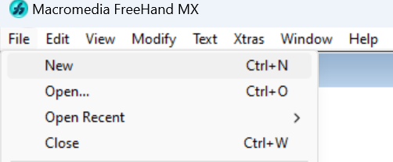

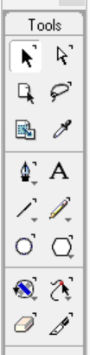**Step 2:** (Creating the Basic Shapes)

Draw the Outer Circle:

Select outer circle and click “ctrl + shift + d’ to duplicate the outer circle.

Hold ctrl + shift and resize the small circle as per your need.

**Step 3:** Creating the Hexagram (Star of David)

Draw the Triangles:

Select the Polygon Tool and set the number of sides to 3 in the properties panel.

Draw an equilateral triangle inside the inner circle.

Duplicate and rotate the triangle to form the hexagram.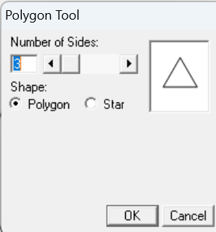

**Step 4:** (Adding the Stars)

Draw the Stars:

Select the Star Tool from the toolbar.

Click and drag to create a star shape on one side of the inner circle.

Hold the Shift key to maintain symmetry.

Duplicate the star and drag it to other side

Fill color from right side(properties bar).

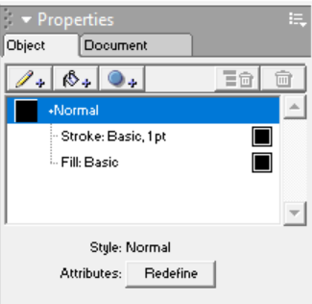

**Step 5:(**Adding text)

Duplicate the inner Circle (Ctrl + shift + D)

Select the duplicated circle and open text tab -> Attach to path.

Type name, to add address at bottom press enter and type.

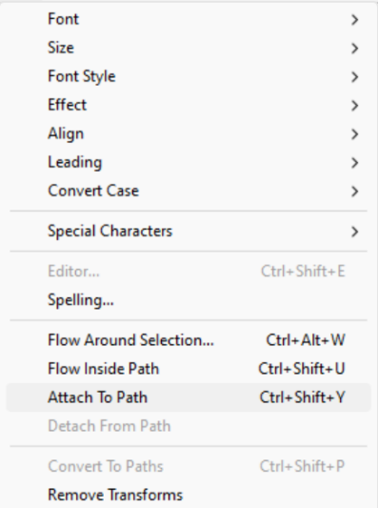

**Step 6:** (Add book)

Get the book symbol by setting the font style as Webdings and click SHIFT+7.



**Step 7:** (Saving the File)

Save the Design:

Go to File > Save As and choose a suitable file format (e.g., Freehand, EPS, or PDF) for future edits.

Also, export the logo in standard image formats like PNG or JPEG for use in various applications.

**Conclusion:**

The step-by-step approach involved setting up the workspace, crafting basic shapes, incorporating symbolic elements like stars and a hexagram, and integrating a central book icon to represent knowledge. Adding text with the college's name and location provided the final touch to ensure the logo is informative and professional.

**TITLE: CREATE A GIF USING ADOBE PHOTOHOP CONCEPT**

A GIF (Graphics Interchange Format) is a bitmap image format that supports both static and animated images. It is commonly used on the web for its ability to support animations and transparent backgrounds, and it is limited to a palette of 256 colors. Some of the tips for creating gif are: Keep your GIF file size small to ensure it loads quickly online, limit the number of colors and simplify the design also use twining (adding intermediate frames) for smoother transitions. GIFs are generally more effective when they are short and loop seamlessly.

**PROCEDURES**

**Step 1:**

Select an image and create 4 layers of it.

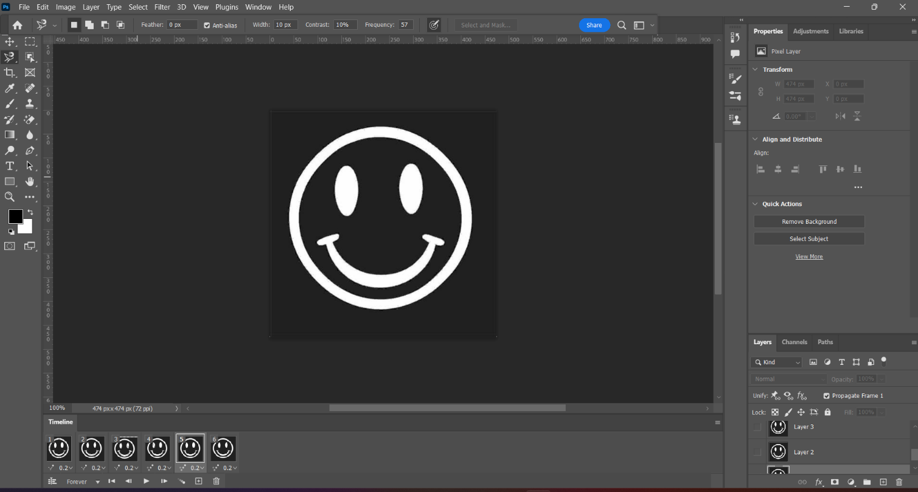

**Step 2:**

Make layer 2 only visible and by using select and magic eraser tool click on its right eye and mouth to remove background

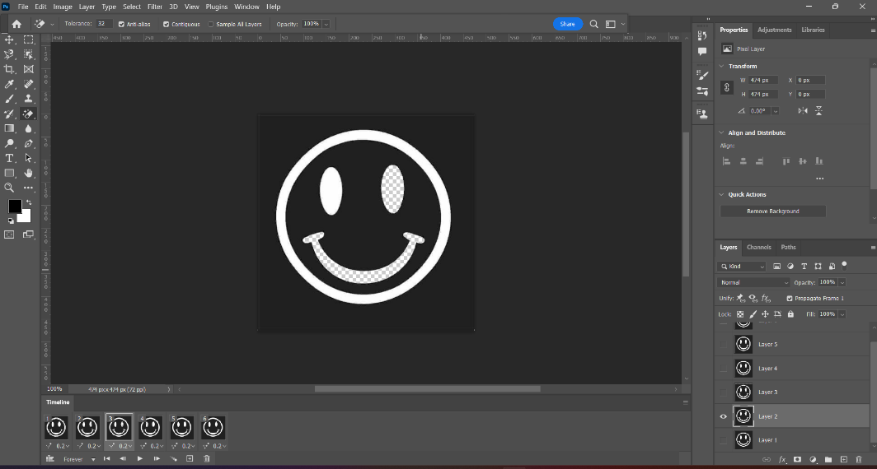

**Step 3:**

Similarly, make layer 3 only visible and remove right eye background. Then, make layer 4 only visible and remove outer border.

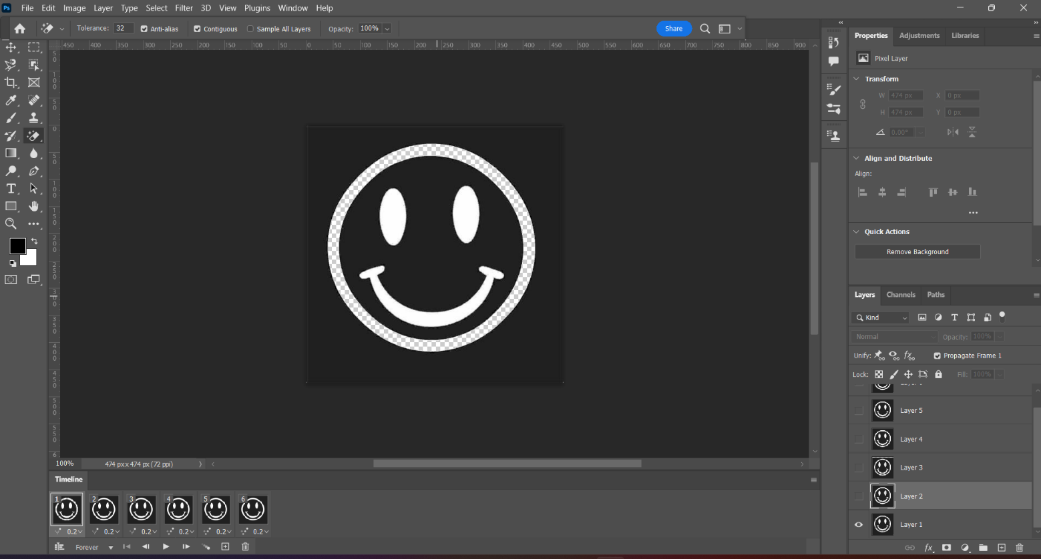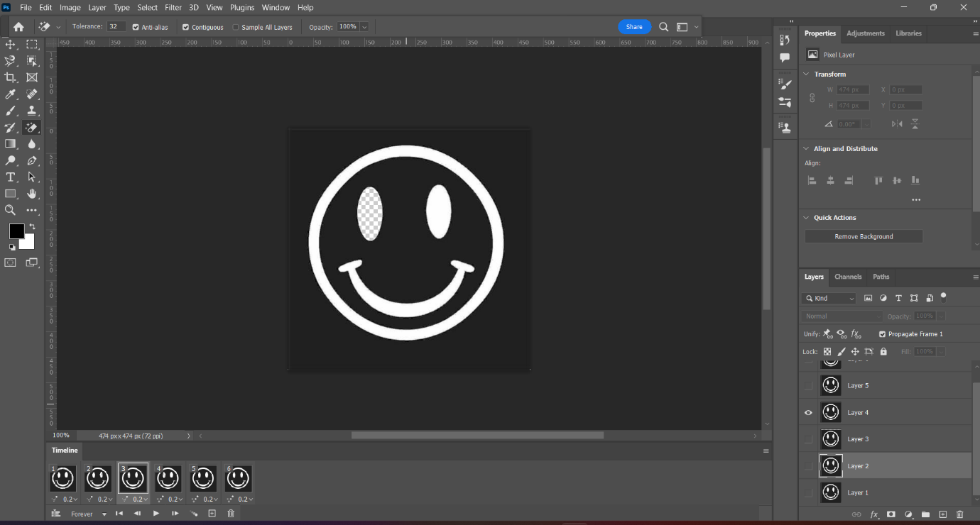

layer:3 layer:4

**Step 4:**

Now, make all the layers visible, go to Windows and click on timeline then, click on ‘Make frame animations. Set all the timings of the layers as 0.2 seconds. Lastly, go to file and click on save for web.

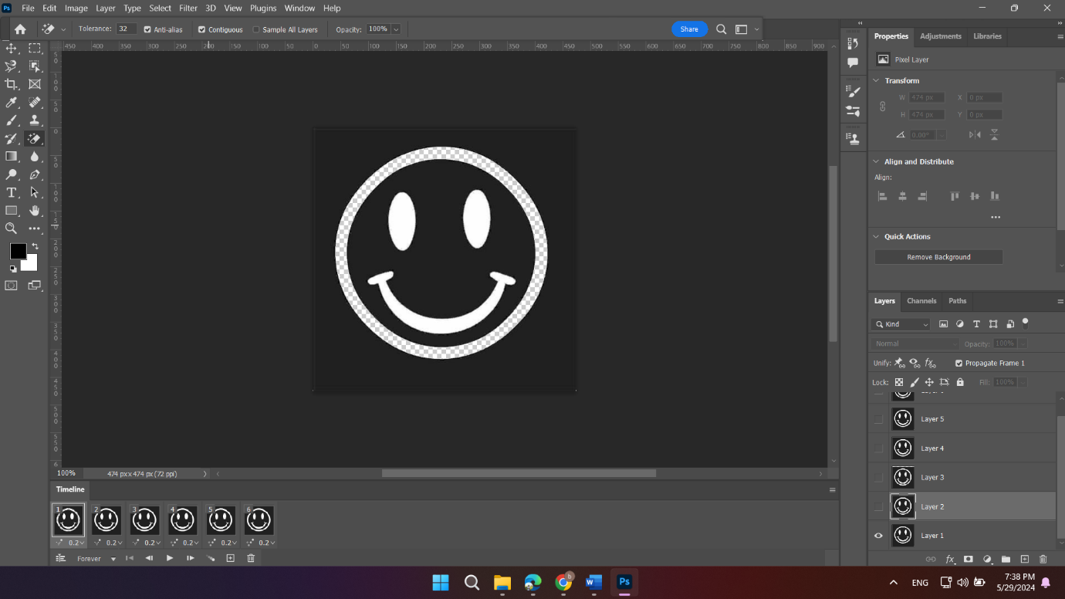

**CONCLUSION**

Hence, we can create a GIF using Adobe Photoshop.